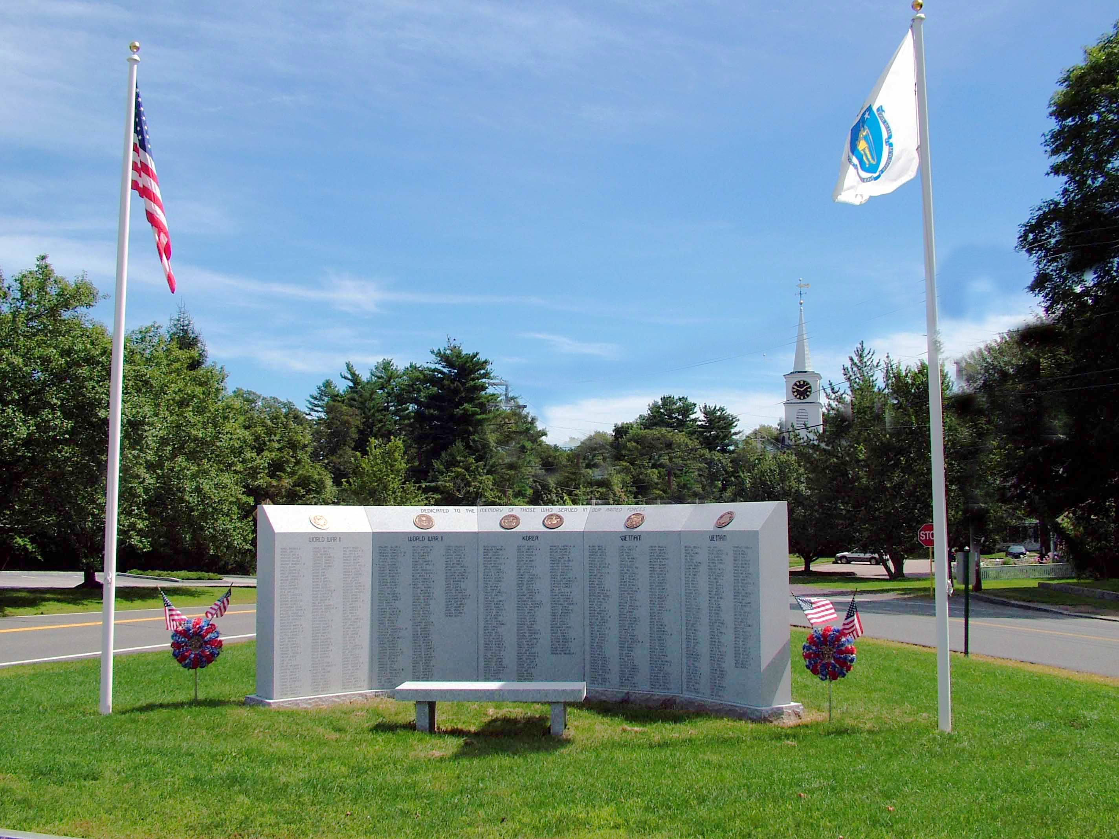

7:00 Open
Call to Order

7:35 Library Board of Trustees – Sunday Hours

8:00 Fire / Police Department Update

Approval of Minutes

Appointments

Old Business

New Business
- Approve Inter-fund Borrowing

Upcoming Meetings

Announcements

Adjournment

Executive Session – Union and Personal Contracts

